Polish Your Github and LinkedIn Profiles

**“41% of employers say that they might not interview a candidate if they can’t find them online.”**

**–** [**CareerBuilder**](https://www.careerbuilder.com/share/aboutus/pressreleasesdetail.aspx?sd=4%2F28%2F2016&id=pr945&ed=12%2F31%2F2016)​

**Key Takeaways:**

1. By the end of this Milestone, you will be able to develop or polish your professional online profiles.
2. After reviewing the guide below, develop your Github and LinkedIn profile, and [submit to a Profile Coach on BCS for feedback](https://www.bootcampspot.com/login).
3. For more insight on building a LinkedIn profile, [click here to view a “Polishing Your LinkedIn Profile” workshop](https://youtu.be/iFXyVNKaI_U).

Your **online materials** are just as important as your resume when it comes to getting an interview. With that, it's very important that they give a great impression and show your **professional valu**e. Be on your way to becoming Employer Competitive by developing strong materials that are **tailored to your** **target jobs** and that tell a compelling story of the value you'll add to employers.

For a guided experience on developing one of these online materials, [click here to view a “Polishing Your LinkedIn Profile” workshop](https://youtu.be/iFXyVNKaI_U).

**GETTING STARTED**

1. Review the criteria below to develop or polish your portfolio, Github, and LinkedIn for review by a Profile Coach.
2. If this is your first time developing a LinkedIn profile, you can use the following ‘Step-by-Step’ guide for more support: **LinkedIn.**
3. If you’d like more insight on developing online career materials, see the resources we’ve included at the end of this guide.
4. Once you’re done, [submit links to your materials on the Career Services page in BCS](https://www.bootcampspot.com/login). A Profile Coach will offer unlimited feedback to help you develop an Employer Competitive online presence.

**GITHUB PROFILE CRITERIA**

**Employer Competitive Github**

A competitive Github profile highlights projects that you’re proud of, document them through a readme and in code comments, and presents understandable and reader-friendly code. It shows meaningful contributions both to individual and group projects, clear readmes, and modular, clean code.

Use the following criteria to develop your Github profile. Your Profile Coach will use the same set of criteria when providing feedback.

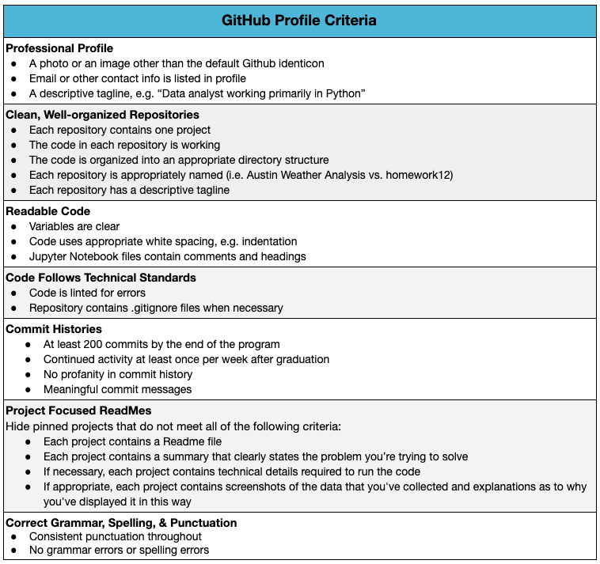

**LinkedIn Profile Criteria**

**Employer Competitive LinkedIn**

An Employer Competitive LinkedIn Profile reflects your personal brand, demonstrates your accomplishments, and showcases your interests. It offers an online presence that speaks to your professional values, and it also helps facilitate more efficient networking.

Use the following criteria to develop your LinkedIn profile. Your Profile Coach will use the same set of criteria when providing feedback.**Note: You can customize your LinkedIn URL.** In the upper-right corner of your profile, you’ll see and can click “Edit public profile and URL”. This is your chance to personalize your URL, which will make you easier to find through Google or Bing.

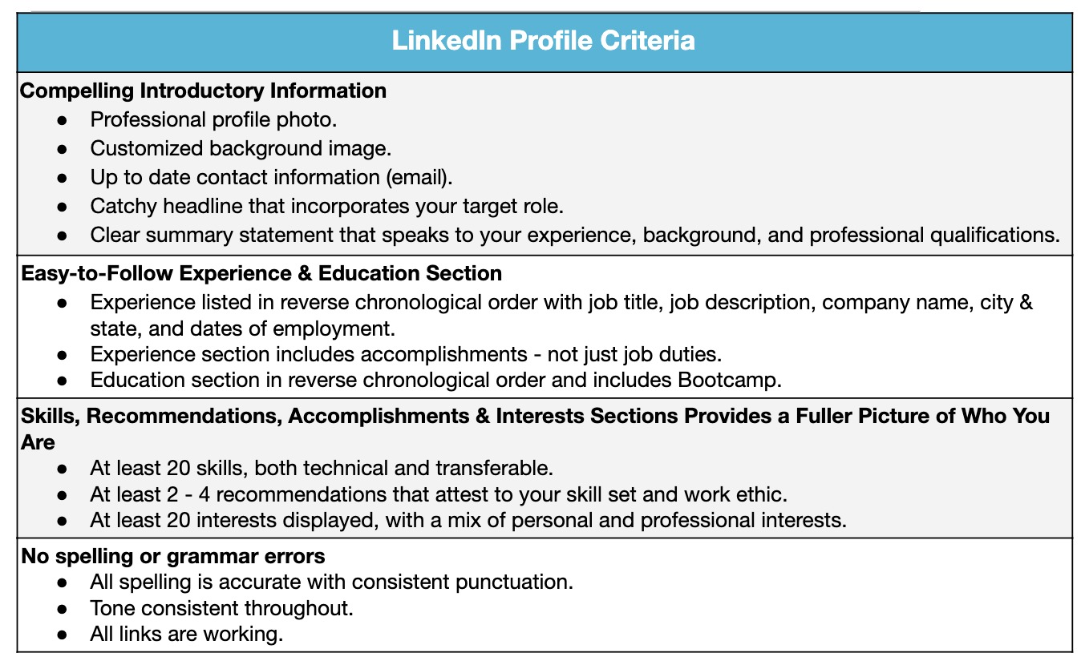

**ADDITIONAL RESOURCES**

* ​[7 LinkedIn Tips that Get You Hired](https://jobhuntingu.com/2014/01/27/7-linkedin-headline-tips-get-hired/)​
* ​[Github Readme Template](https://gist.github.com/PurpleBooth/109311bb0361f32d87a2" \l "file-readme-template-md" \t "_blank)